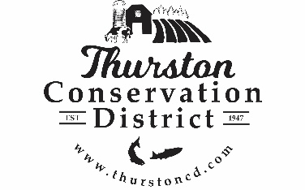
PRESS RELEASE

CONTACT:
Sarah Moorehead
11-21-22 smoorehead@thurstoncd.com

Notice of Potential Quorum

Thursday, October 16, 2025, WACD Southwest Area Meeting
The Board of Supervisors will be attending WACD Southwest Area Meeting on Thursday October 16th 2025, from 9:00 a.m. – 3:00 p.m. at the Wahkiakum Conservation District, Wahkaikum, WA. A quorum of supervisors will be present. No formal actions will be taken.

Please contact us with any questions:
360.754.3588

