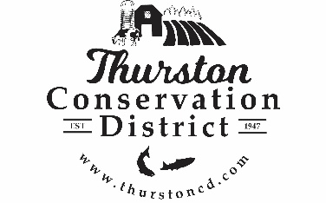
PRESS RELEASE

CONTACT:
Sarah Moorehead
11-21-22 smoorehead@thurstoncd.com

Notice of Potential Quorum

Saturday, October 4, 2025, Harvest Festival
The Board of Supervisors will be attending the Annual Bulb & Seed Sale & Harvest Festival on Saturday October 4th 2025, from 10:00 a.m.– 3:00 p.m. at South Union Grange Hall in Tumwater, WA. A quorum of supervisors will be present. No formal actions will be taken.

Please contact us with any questions:
360.754.3588

