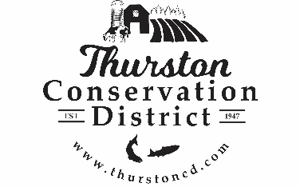
PRESS RELEASE

CONTACT:
Sarah Moorehead
11-21-22 smoorehead@thurstoncd.com

Notice of Potential Quorum

Thursday, September 4, 2025, Legislative Tour
The Board of Supervisors will be attending a Legislative Tour on Thursday September 4th, 2025, from 9:00 a.m. – 3:00 p.m. at various locations throughout Thurston County, WA. A quorum of supervisors will be present. No formal actions will be taken.

Thursday, September 11, 2025, Legislative Tour
The Board of Supervisors will be attending a Legislative Tour on Thursday September 11th, 2025, from 9:00 a.m. – 3:00 p.m. at various locations throughout Thurston County, WA. A quorum of supervisors will be present. No formal actions will be taken.

Please contact us with any questions:
360.754.3588

