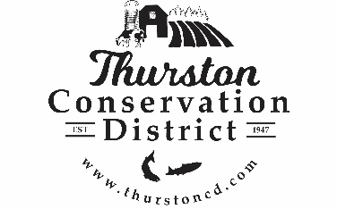
PRESS RELEASE

CONTACT:
Sarah Moorehead
11-21-22 smoorehead@thurstoncd.com

Notice of Potential Quorum

Wednesday, September 3, 2025, Staff & Supervisor Picnic
The Board of Supervisors will be attending an informal staff and supervisor picnic on Wednesday September 3th 2025, from 4:00 p.m.– 6:00 p.m. at Urban Futures Farm in Olympia, WA. A quorum of supervisors will be present. No formal actions will be taken.

Please contact us with any questions:
360.754.3588

