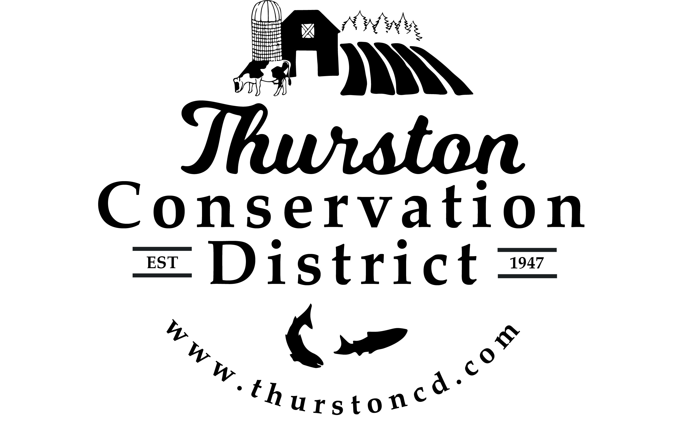
PRESS RELEASE

CONTACT:
Sarah Moorehead
11-21-22 smoorehead@thurstoncd.com

Notice of Potential Quorum

Monday, August 25, 2025, Strategic Planning Meeting
The Board of Supervisors will be attending Strategic Planning Meeting on Monday August 25th 2025, from 1:00 p.m.– 5:00 p.m. at the Thurston Conservation District Offices in Tumwater, WA. A quorum of supervisors will be present. No formal actions will be taken.

Please contact us with any questions:
360.754.3588

