Thurston Conservation district  Supervisor Position Application for Mid-term Elected Seat  Date/Time Application Received: (for official use only)  Application materials must be submitted to: smoorehead@thurstoncd.com | 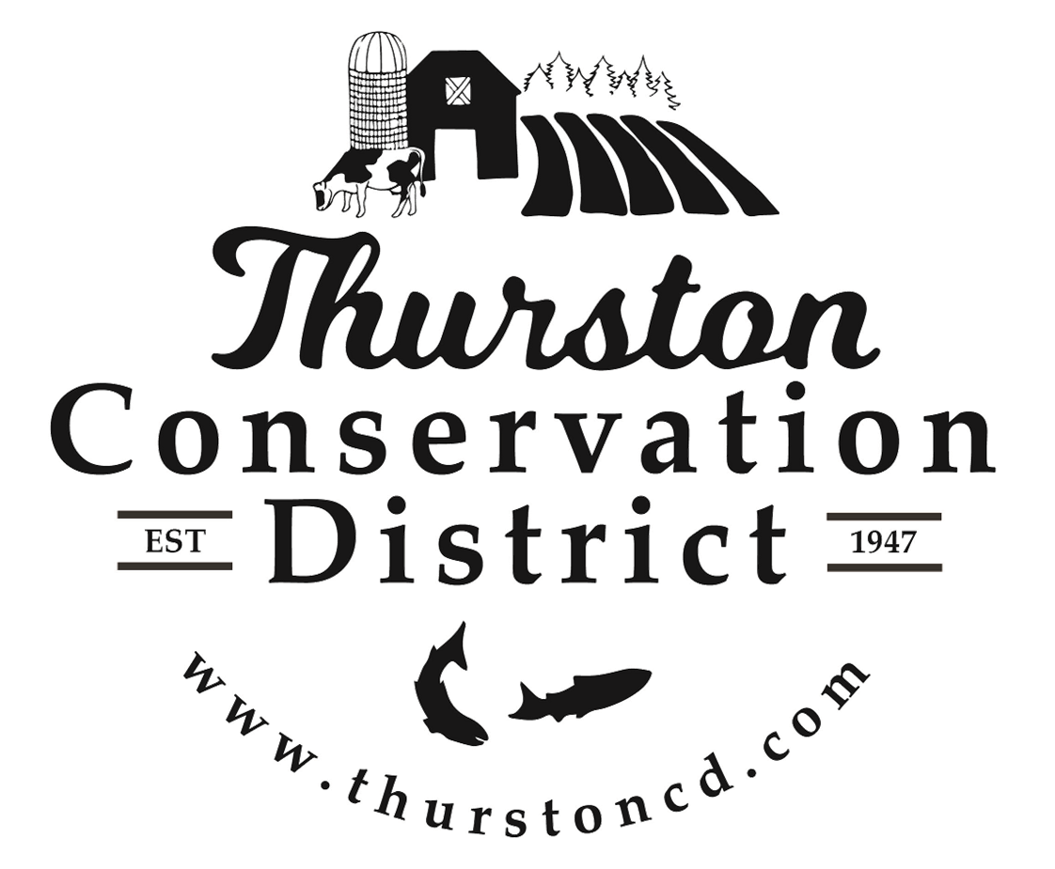

Applicant Contact Information
Last Name |  | First |  |  |  | M.I. | Date
Residential Address
Mailing Address
(if different)
Phone |  |  | E-mail Address

Eligibilty & Discovery
1. | Are you a registered voter in Thurston County?
 | YES NO
2. | Do you reside within Thurston Conservation District’s boundaries?
 | YES NO
3. | Do you own land or operate a farm within Thurston Conservation District’s boundaries, as defined in the WAC 135-110-110?
 | Own land Operate a farm
4. | If you own or operate a farm, please describe:
5. | Have you ever served as a conservation district supervisor before?
 | YES NO
6. | If yes, where and when did you serve? And, why did you leave?
7. | What is your current occupation?
8. | Please describe your experience with boards and organizations that will help you fulfill your duty as a conservation district supervisor, if you are appointed.
9. | What special training, skills, and experiences do you have that will help you execute the duties of a conservation district board supervisor?
10. | Why are you interested in serving as a conservation district board supervisor?
11. | Describe what experience you have had with Washington Conservation Districts (such as a Conservation Plan).
12. | Do you have any prior experience reviewing contracts or other legal instruments? If so, please describe.
13. | Describe any previous experience you have as a participant in a collaborative process.
14. | Describe any previous experience with installing practices on a farm.
15. | Please describe other previous experience with natural resource management.
16. | Please describe any experience with adult and youth education and/or public outreach.
17. | How would you engage underrepresented members of our community?

Community References
Please provide contact information for at least three organizations you have volunteered or partnered with in our community. These organizations / individuals will be contacted during the vetting process.

Preferences:
Natural resource management focused organizations
Organizations that work with Thurston Conservation District
Organization |  |  |  |  | Your Role
Contact Person |  |  |  |  | Email
Address |  |  |  | Phone
Description of Work
Organization |  |  |  |  | Your Role
Contact Person |  |  |  |  | Email
Address |  |  |  | Phone
Description of Work
Organization |  |  |  |  | Your Role
Contact Person |  |  |  |  | Email
Address |  |  |  | Phone
Description of Work

Disclaimer and Signature
By my signature below, I swear under penalty of perjury under the laws of the State of Washington that the foregoing information is true and correct. _{WAC 135-110-320(3)f}
Signature |  | Date

