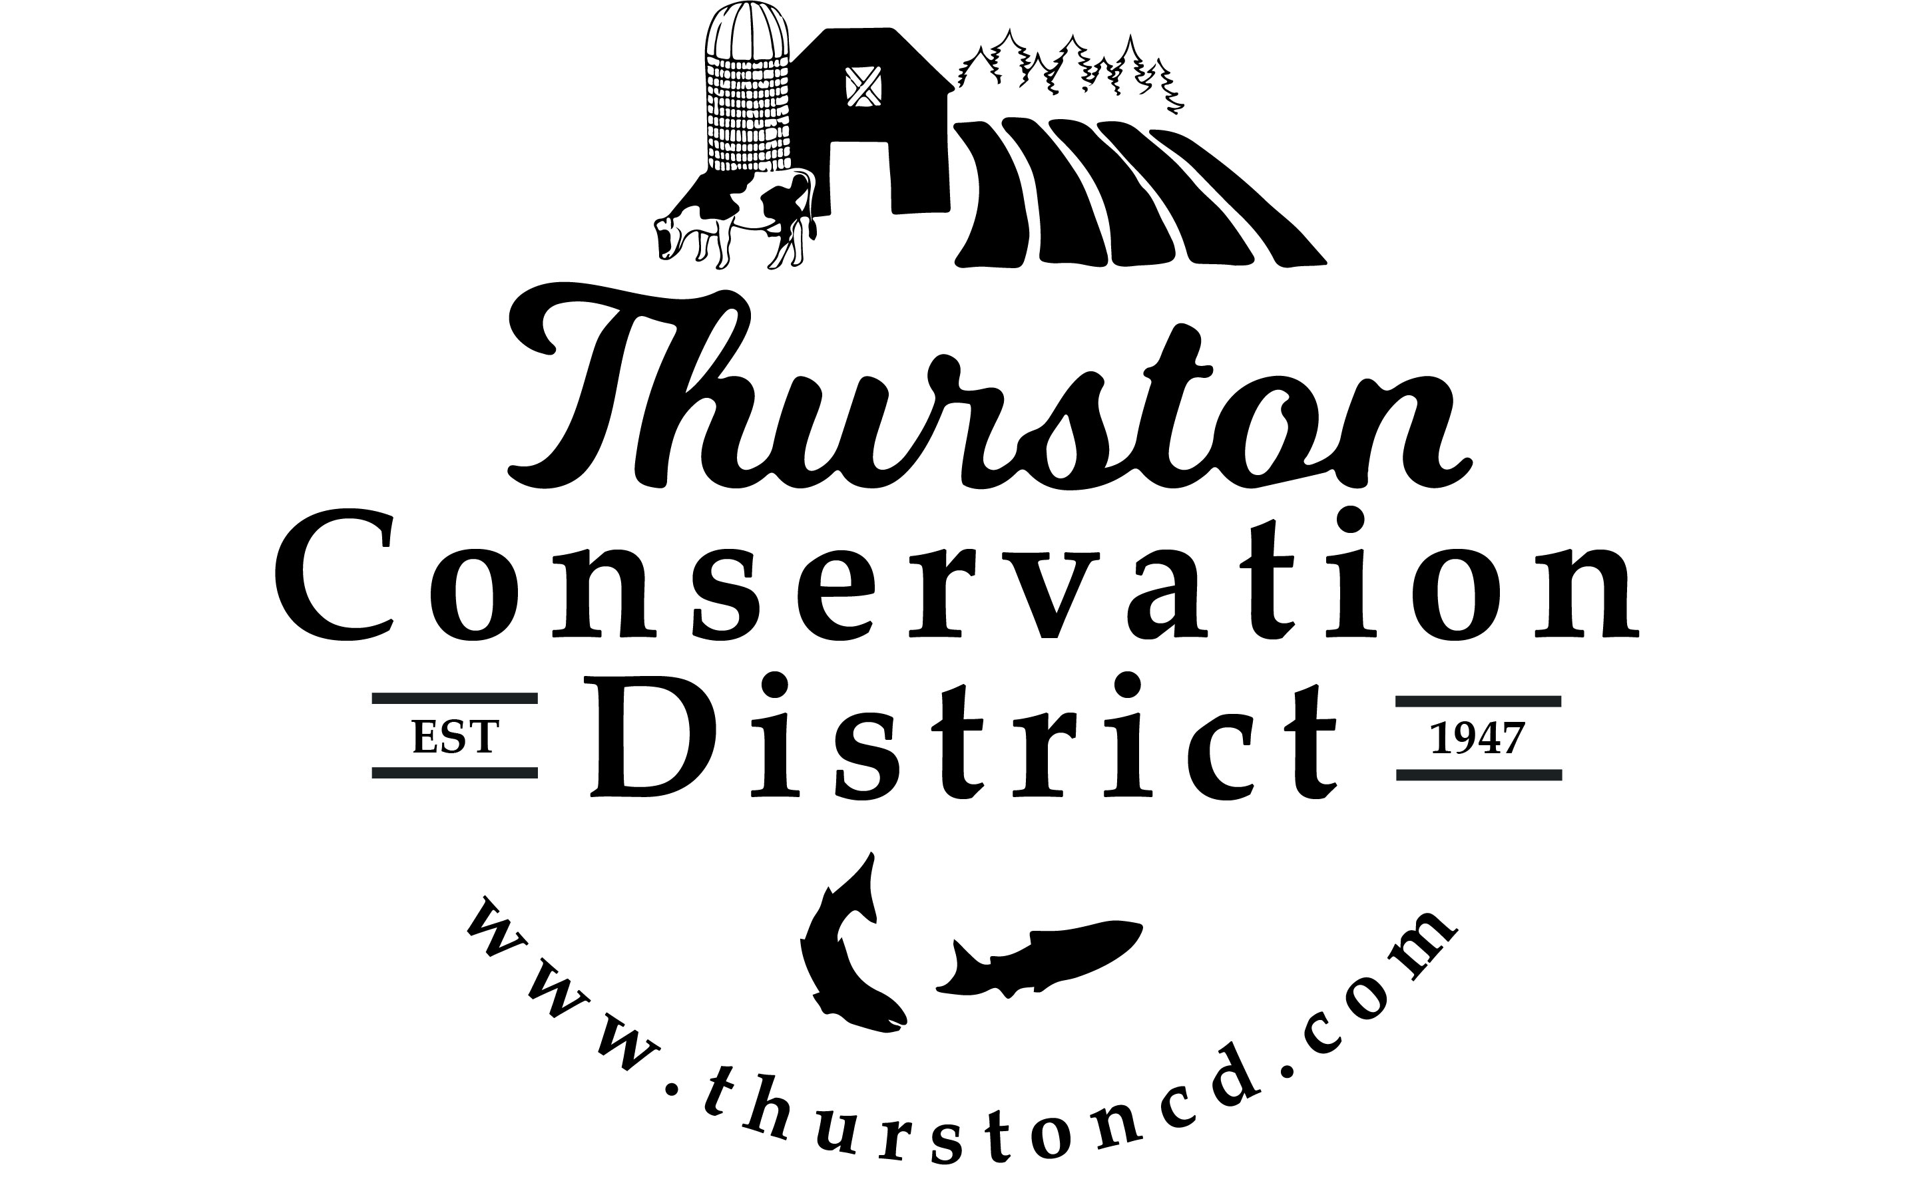
TCD Board of Supervisors
Monthly Meeting Agenda
Tuesday, May 29th, 2018 (2:00 pm)
2918 Ferguson St SW, Suite A, Tumwater, WA 98512, 360.754.3588

No. Item Time Allotted Tab #
- Welcome, Introductions, Audio Recording Announcement 5 minutes
and Pledge of Allegiance
- Executive Session: RCW 89.08.110 To receive and evaluate 30 minutes
complaints or charges brought against a public officer or employee.

- Executive Session: RCW 89.08.110 To evaluate the qualifications 30 minutes
of an applicant for public employment or to review the performance
of a public employee.

- Public Comment 20 minutes
Individuals have 3 minutes each to provide comment, please sign in on our public
comment sign-up sheet.

- Agenda Review 3 minutes
  - Agenda Format

- TCD Board Meeting & Work Session Discussion 10 minutes

- Partner Reports: 1
  - NRCS, Jeff Swotek 3 minutes
  - WSCC, Shana Joy 3 minutes
  - WACD/NACD, Doug Rushton 3 minutes

- Financial Report, Sarah Moorehead 35 minutes 2
- Monthly Financial Report
- May Check Register – Action Item
- Schedule 22: State Auditor Report – Action Item
- WSCC 2018 Natural Resource Investment Cost Share Addendum – Action Item
- Resolution #2018-03: Authorized Bank Signers – Action Item
- Shellfish Fund: Nearshore 2018 Watershed Exploration and Enhancement ILA – Action Item

- Rates & Charges 20 minutes 3
  - May 10th, 2018 Public Hearing Debrief
  - Resolution #2018-01: Adopting a System of Rates and Charges – Action Item
  - Resolution #2018-02: Establishing a Process for Landowner
Appeals of Rates and Charges– Action Item
  - Scheduling Board of County Commissioners Briefing

- Conservation Projects 10 minutes 4
  - East Fork McLane Creek Bridge Installation Construction Contract – Action Item
  - Water Quality Improvement Project Cost Share Agreement – Action Item
  - Fish Passage Project Cost Share Agreement – Action Item

- Associate Supervisor Discussion 10 minutes
- Board Meeting Minutes Review, All – Action Items 40 minutes 5
(Information only: April 24th, 2018 action items report)
  - April 24, 2018 Regular Meeting & Work Session minutes
  - November 21, 2017 Special Meeting & Work Session minutes
  - December 20, 2017 Regular Meeting & Work Session minutes

- 2018 Annual Plan, All – Action Item 10 minutes 6

- Review of TCD Governance Action Plan, All 10 minutes 7

- Policies & Procedures, All – Action Item 10 minutes

- Adjourn, All

Total Time Allotment: 252 minutes (4.20 hrs)

Administrative Reports (Informational Only) 8
- Interim Executive Director Report

