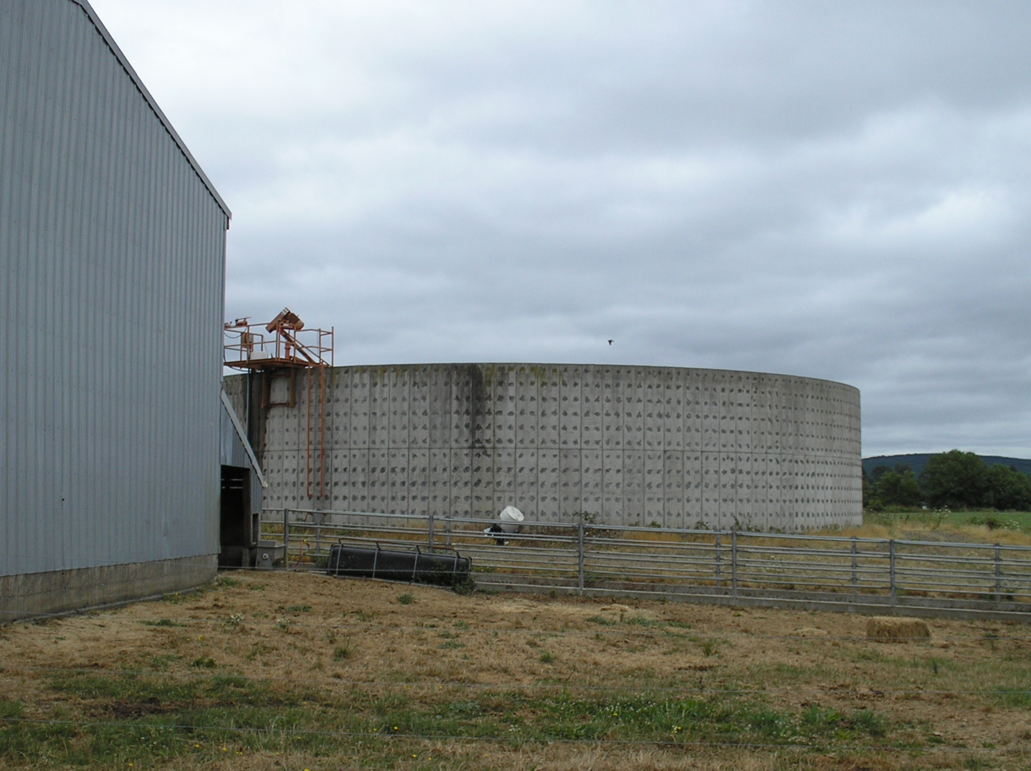
Thurston Conservation District
State Legislative District #2, 20, 22, 35
Congressional District #3, 9
Other Accomplishments2009 Feature Accomplishment Contact Information
~Residential land consumption is expected to rise by 11,881 acres in rural Thurston Co. in the next 4 years. Dedicated funding is desperately needed to protect working lands and reduce land use conversion.

~ A 2004 study of riparian areas showed that 258.9 miles were in degraded condition. Since that date, we have restored just over 19 miles. Additional funding is needed to continue this work.

Project Summary and Results
The Thurston, Lewis, and Grays Harbor Conservation Districts formed the “Chehalis District Alliance” to address the fecal coliform issues throughout the watershed after the listing was announced. This cooperative effort continues today. This year, DOE announced plans to delist two segments, due in large part to the work of the District. This report addresses the work Thurston CD accomplished in the Chehalis segments between 1998-2008.

Between this period, TCD worked with 203 landowners, developing 59 Conservation Plans and implementing 1,154 Best Management Practices (BMPs). All twelve (12) dairies that had been located in the watershed (8 are no longer in operation) worked with the district to develop and fully implement Dairy Nutrient Management Plans. Of the BMPs implemented, 64,058 feet of riparian fence was installed and 118 manure storage structures were installed. Riparian planting projects covered 19,690 feet of stream (consisting of 17,935 native plants).

Key Project Partners
Natural Resources Conservation Service, Washington State Conservation Commission. WA State Department of Ecology, Conservation Reserve Enhancement Program, Northwest Pipeline, Lewis Co and Gray Harbor Conservation Districts.

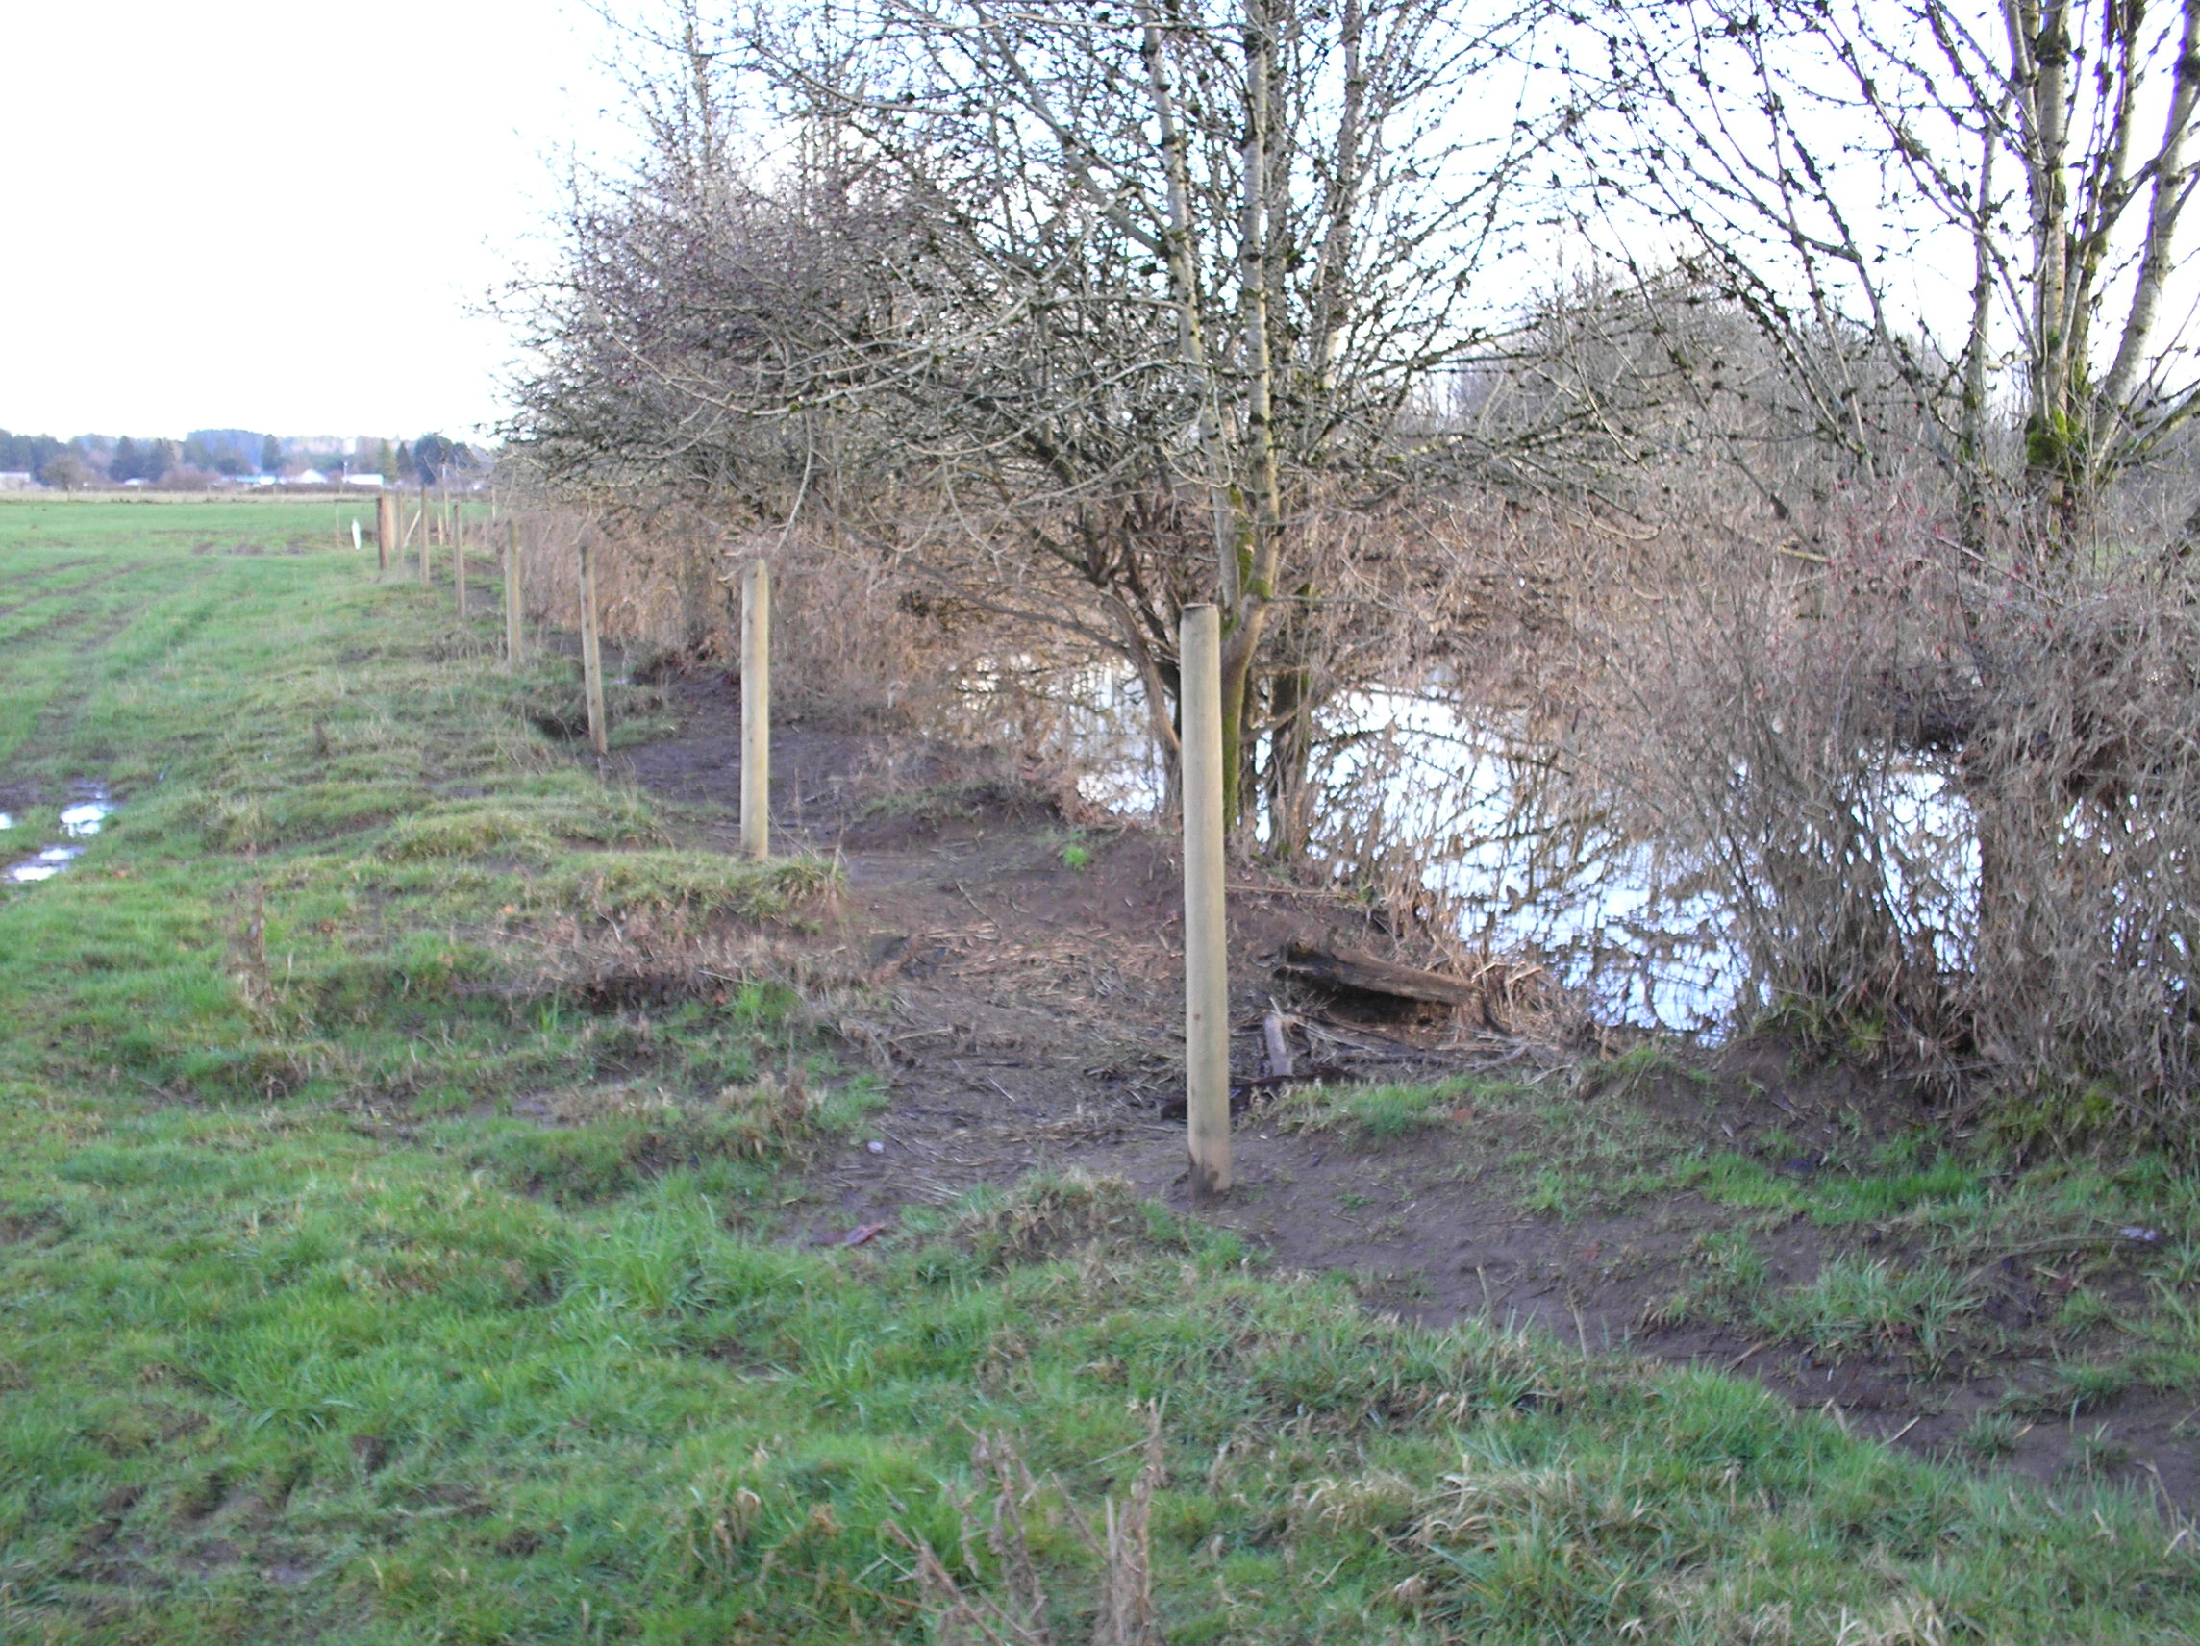
BMPs Implemented Result in 2 Segments of Chehalis River Being Removed From 303(d) List

Resource Challenge
28 segments of the Chehalis and its tributaries were listed in the 1996/98 303(d) list of impaired water for fecal coliform, due in part, to agricultural activities.

~ 28,831 feet of fence replaced & 692 acres flood debris removed following 2007 Chehalis Flood.

~ 110 residents sign up for Clear Choices for Clean Water incentive- based program.

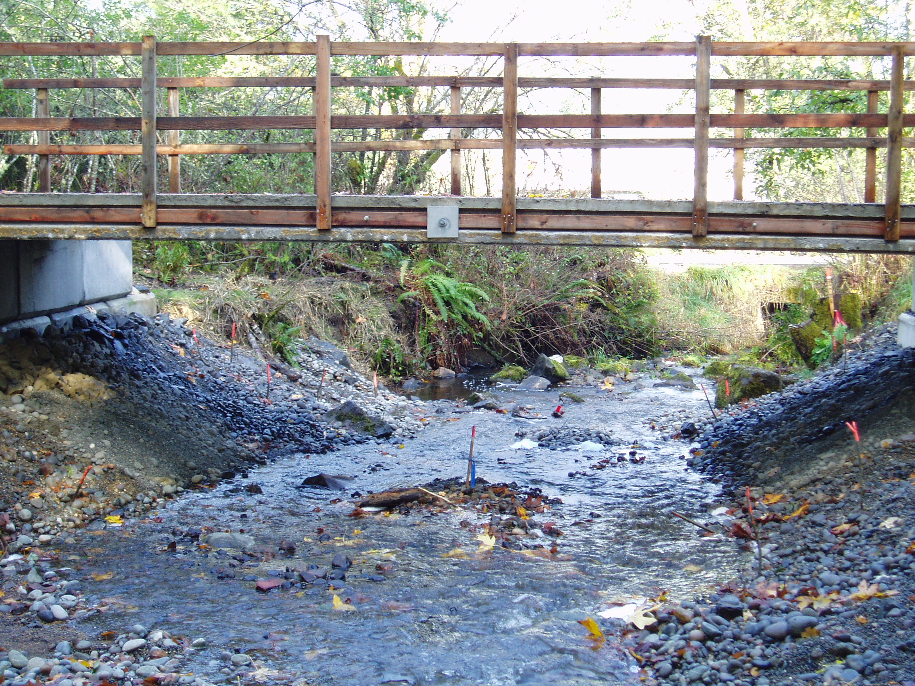
600,000 gallon Manure/ Wastewater Storage Tank constructed on Dairy (1999)
Bridge installed with pre-cast concrete panels on Crawford Ck
15,000’ riparian fence installed on a Chehalis River farm
More Work To Do
Kathleen Whalen, District Administrator
2918 Ferguson St. SW, Suite A
Tumwater, WA 98512
(360) 754-3588 ext.114
kwhalen@thurstoncd.com
www.thurstoncd.com

Board of Supervisors:
Doug Rushton, Chair
Fred Colvin, Treasurer
Nora Mena, Member
David Hall, Member
Dan Cathers, Member

